# Question

Given a root node reference of a BST and a key, delete the node with the given key in the BST. Return the root node reference (possibly updated) of the BST.

Basically, the deletion can be divided into two stages:

1. Search for a node to remove.
2. If the node is found, delete the node.

**Follow up:** Can you solve it with time complexity O(height of tree)?

**Example 1:**

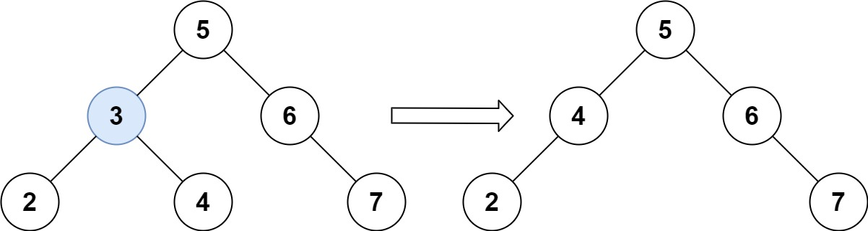

**Input:** root = [5,3,6,2,4,null,7], key = 3

**Output:** [5,4,6,2,null,null,7]

**Explanation:** Given key to delete is 3. So we find the node with value 3 and delete it.

One valid answer is [5,4,6,2,null,null,7], shown in the above BST.

Please notice that another valid answer is [5,2,6,null,4,null,7] and it's also accepted.

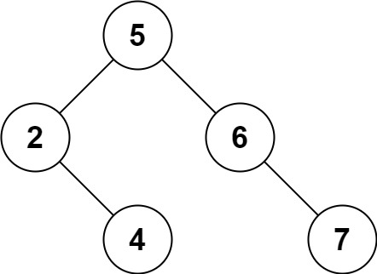

**Example 2:**

**Input:** root = [5,3,6,2,4,null,7], key = 0

**Output:** [5,3,6,2,4,null,7]

**Explanation:** The tree does not contain a node with value = 0.

**Example 3:**

**Input:** root = [], key = 0

**Output:** []

**Constraints:**

* The number of nodes in the tree is in the range [0, 104].
* -105 <= Node.val <= 105
* Each node has a **unique** value.
* root is a valid binary search tree.
* -105 <= key <= 105

# Solution

#### **Three facts to know about BST**

Here is list of facts which are better to know before the interview.

Inorder traversal of BST is an array sorted in the ascending order.

To compute inorder traversal follow the direction Left -> Node -> Right.

|  |
| --- |
| public LinkedList<Integer> inorder(TreeNode root, LinkedList<Integer> arr) {  if (root == null) return arr;  inorder(root.left, arr);  arr.add(root.val);  inorder(root.right, arr);  return arr;  } |

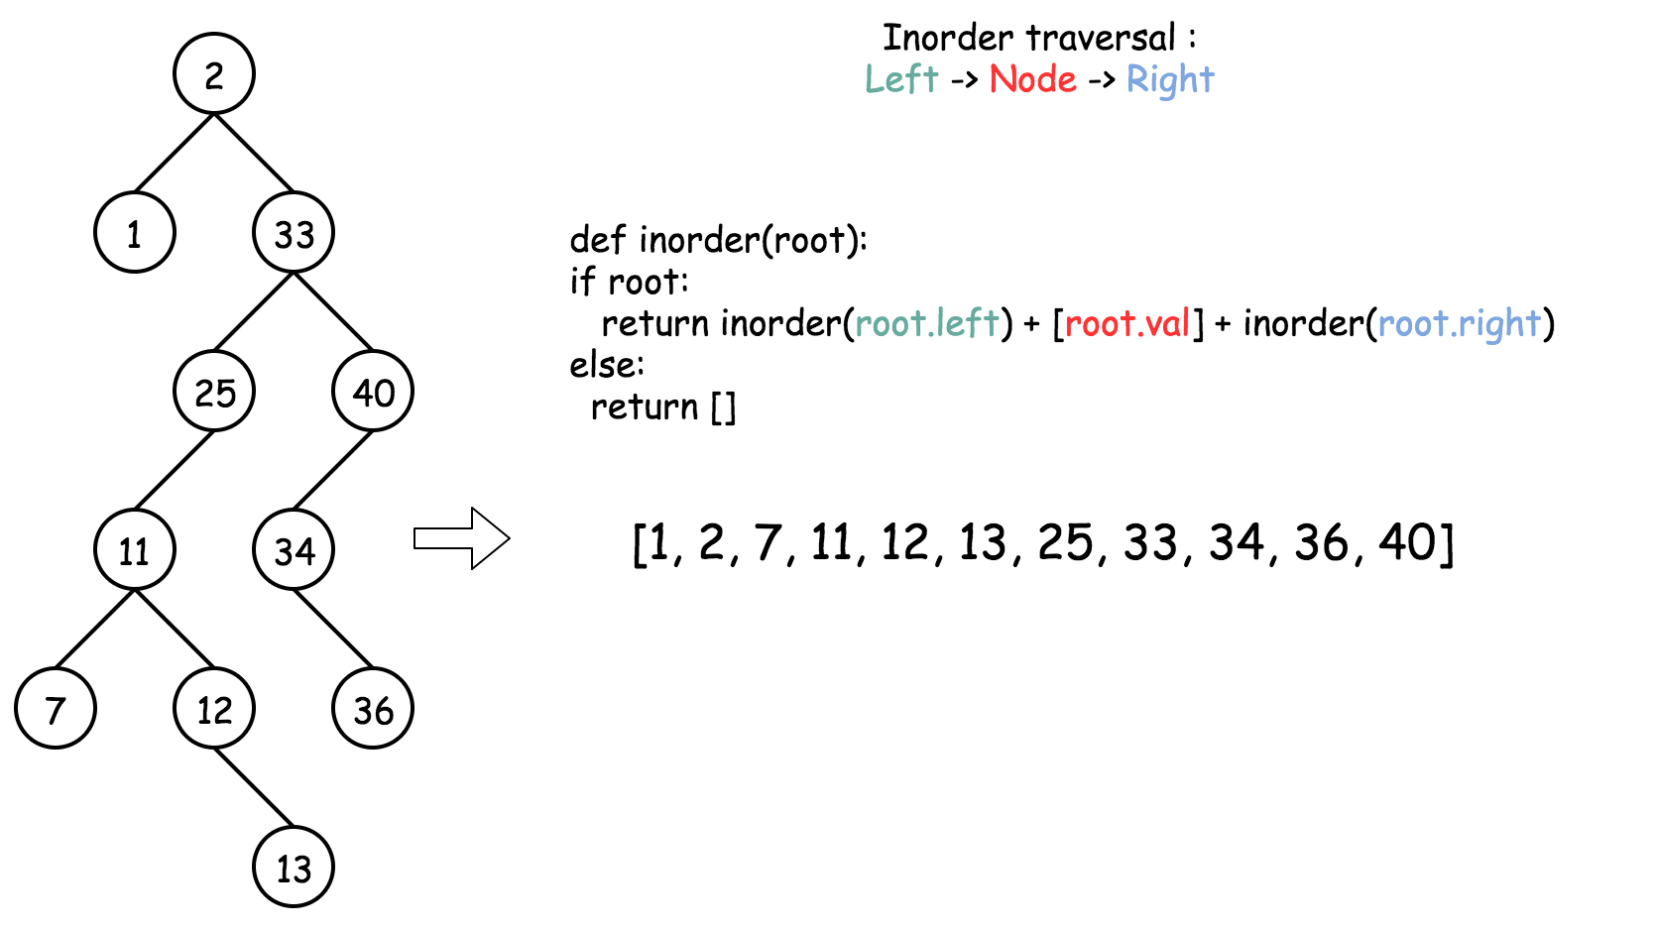

Successor = "after node", i.e. the next node, or the smallest node after the current one.

It's also the next node in the inorder traversal. To find a successor, go to the right once and then as many times to the left as you could.

|  |
| --- |
| public int successor(TreeNode root) {  root = root.right;  while (root.left != null) root = root.left;  return root;  } |

Predecessor = "before node", i.e. the previous node, or the largest node before the current one.

It's also the previous node in the inorder traversal. To find a predecessor, go to the left once and then as many times to the right as you could.

|  |
| --- |
| public int predecessor(TreeNode root) {  root = root.left;  while (root.right != null) root = root.right;  return root;  } |

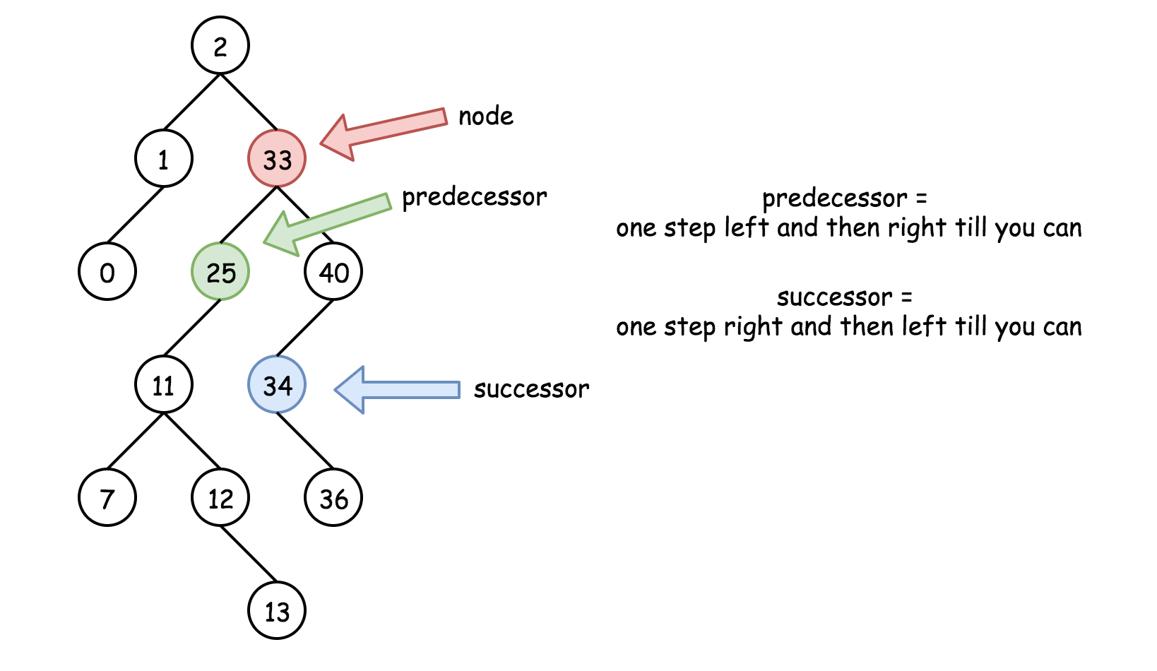

#### **Approach 1: Recursion**

**Intuition**

There are three possible situations here :

* Node is a leaf, and one could delete it straightforward : node = null.

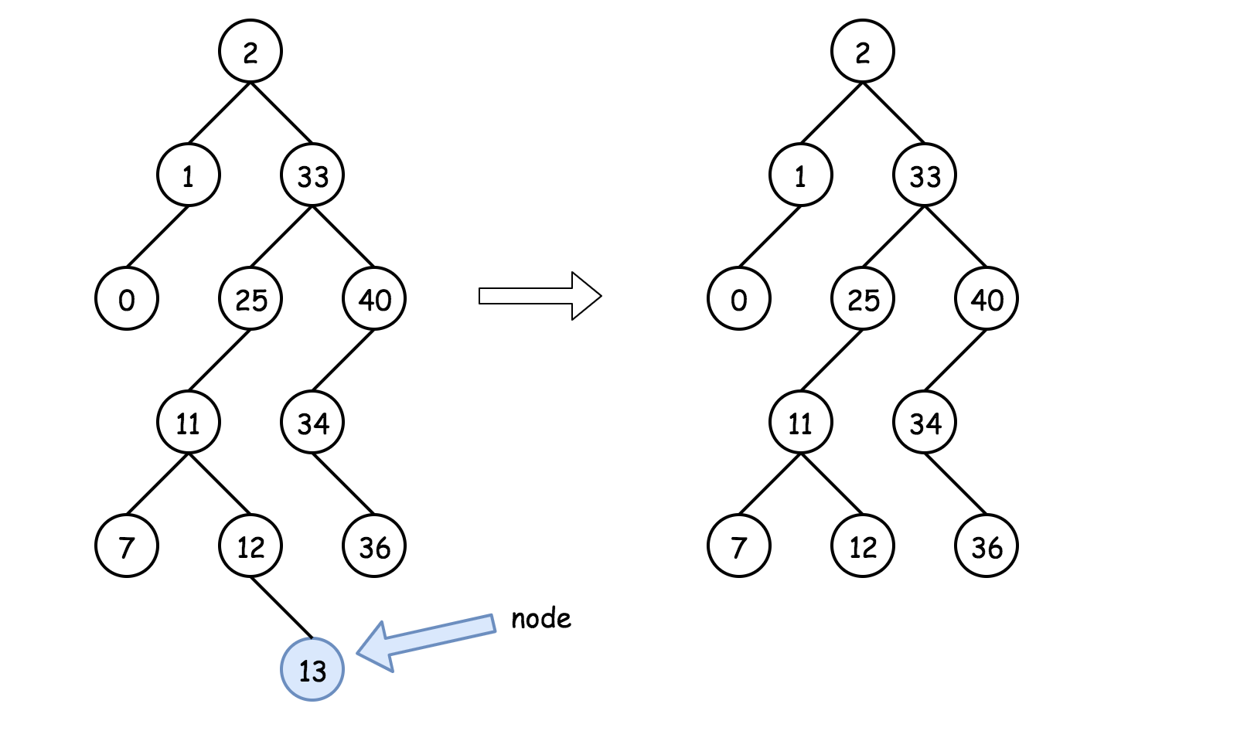

* Node is not a leaf and has a right child. Then the node could be replaced by its successor which is somewhere lower in the right subtree. Then one could proceed down recursively to delete the successor.

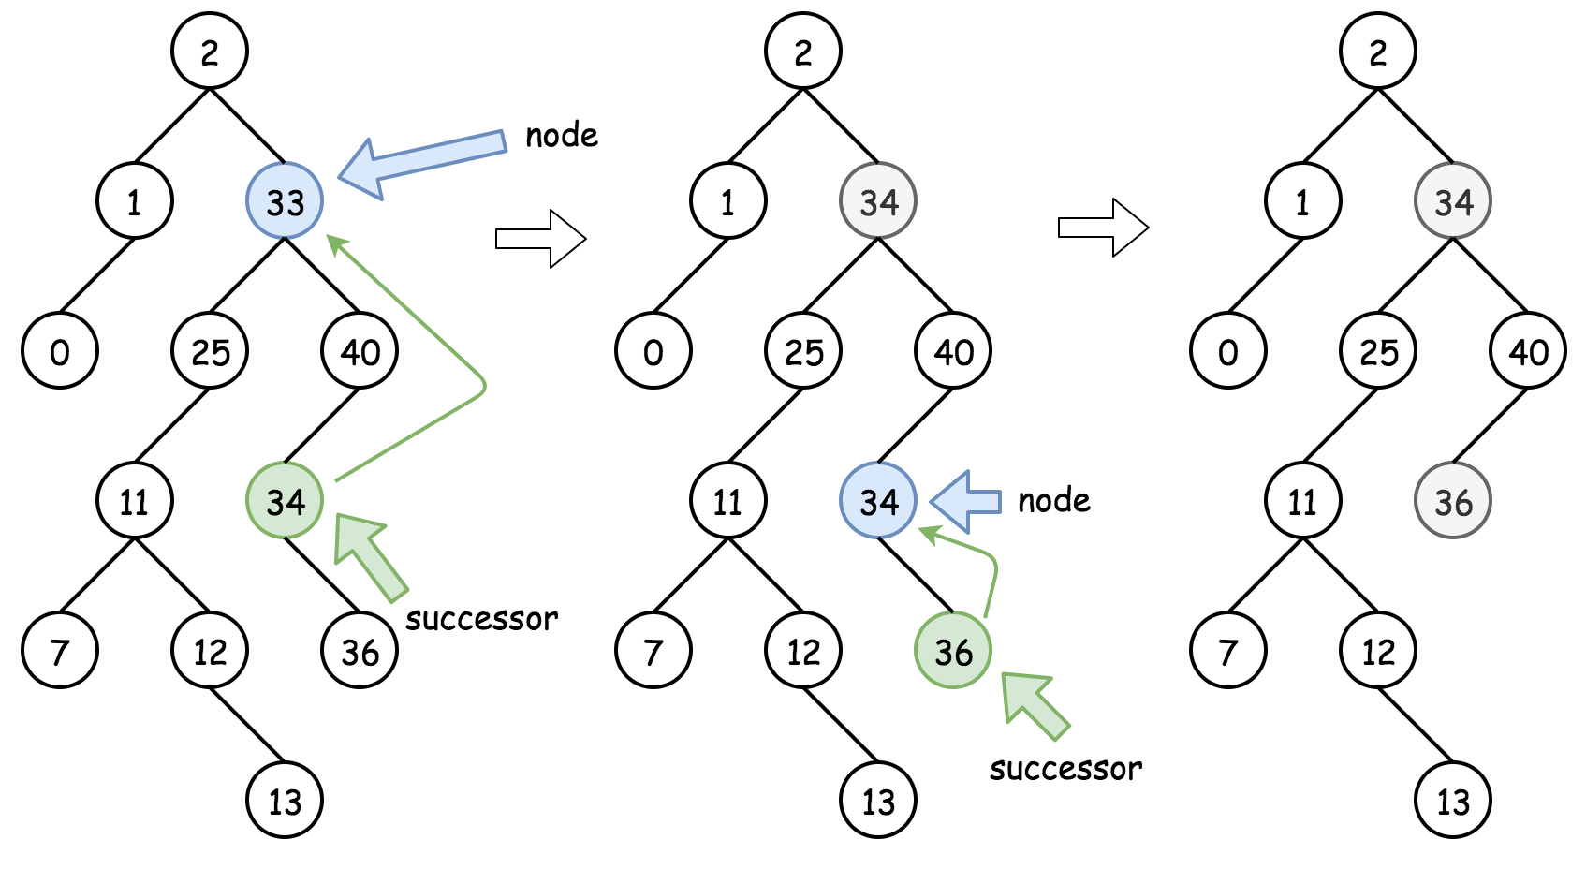

* Node is not a leaf, has no right child and has a left child. That means that its successor is somewhere upper in the tree but we don't want to go back. Let's use the predecessor here which is somewhere lower in the left subtree. The node could be replaced by its predecessor and then one could proceed down recursively to delete the predecessor.

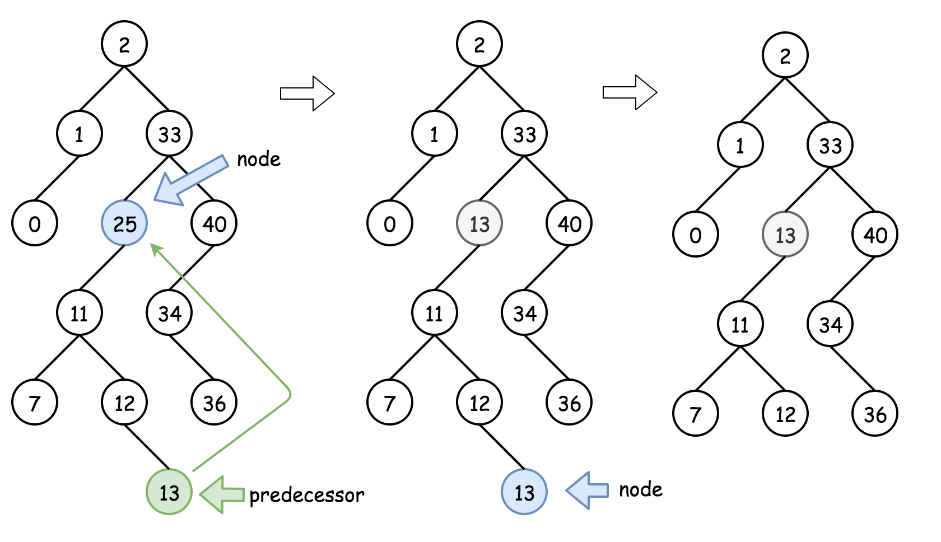

**Algorithm**

* If key > root.val then delete the node to delete is in the right subtree root.right = deleteNode(root.right, key).
* If key < root.val then delete the node to delete is in the left subtree root.left = deleteNode(root.left, key).
* If key == root.val then the node to delete is right here. Let's do it :
  + If the node is a leaf, the delete process is straightforward : root = null.
  + If the node is not a leaf and has the right child, then replace the node value by a successor value root.val = successor.val, and then recursively delete the successor in the right subtree root.right = deleteNode(root.right, root.val).
  + If the node is not a leaf and has only the left child, then replace the node value by a predecessor value root.val = predecessor.val, and then recursively delete the predecessor in the left subtree root.left = deleteNode(root.left, root.val).
* Return root.

**Implementation**

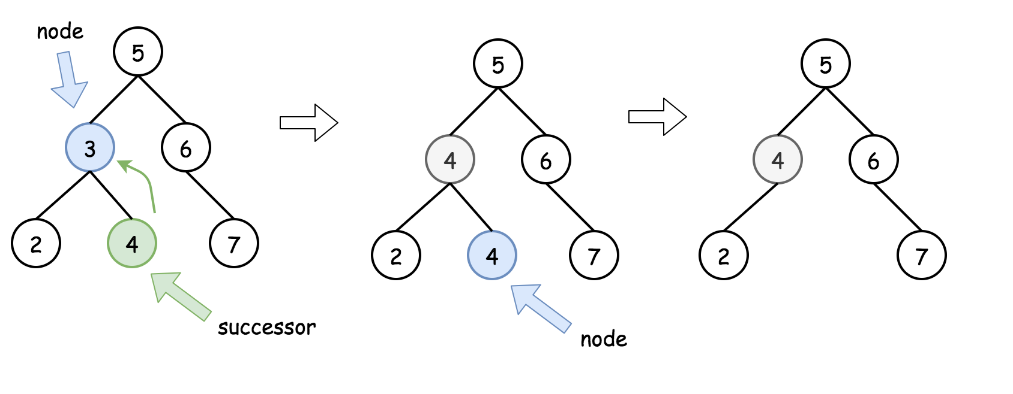

|  |
| --- |
| **class Solution {**  **/\***  **One step right and then always left**  **\*/**  **public int successor(TreeNode root) {**  **root = root.right;**  **while (root.left != null) root = root.left;**  **return root.val;**  **}**  **/\***  **One step left and then always right**  **\*/**  **public int predecessor(TreeNode root) {**  **root = root.left;**  **while (root.right != null) root = root.right;**  **return root.val;**  **}**  **public TreeNode deleteNode(TreeNode root, int key) {**  **if (root == null) return null;**  **// delete from the right subtree**  **if (key > root.val) root.right = deleteNode(root.right, key);**  **// delete from the left subtree**  **else if (key < root.val) root.left = deleteNode(root.left, key);**  **// delete the current node**  **else {**  **// the node is a leaf**  **if (root.left == null && root.right == null) root = null;**  **// the node is not a leaf and has a right child**  **else if (root.right != null) {**  **root.val = successor(root);**  **root.right = deleteNode(root.right, root.val);**  **}**  **// the node is not a leaf, has no right child, and has a left child**  **else {**  **root.val = predecessor(root);**  **root.left = deleteNode(root.left, root.val);**  **}**  **}**  **return root;**  **}**  **}** |

**Complexity Analysis**

